In each case, you as the programmer must enter the expression, but Python does the hard part of evaluating it down to a single value. Python will keep evaluating parts of the expression until it becomes a single value, as shown in [Figure 1-1](https://automatetheboringstuff.com/chapter1/#calibre_link-102).

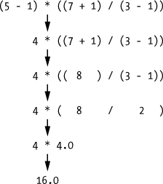

Figure 1-1. Evaluating an expression reduces it to a single value.